

**Case IH Agriculture Equipment, Inc**.

**For More Information, contact:**

Dan Danford 262/636-7359

[dan.danford@cnh.com](mailto:dan.danford@cnh.com)

or

Ryann Greve 262/636-5921

[ryann.greve@cnh.com](mailto:ryan.greve@cnh.com)

**Press Materials**

**CASE IH TWIN-ROW PLANTERS OFFER INNOVATIVE TECHNOLOGY**

**RACINE, Wis.** (August 21, 2012)

Advanced twin-row seeding technology is now available from Case IH for 2013. Accurate, dependable Case IH Twin-Row planters provide a best-in-class solution to increase plant populations without changing cropping practices.

“Twin-row crop production is increasing in popularity due to the potential yield advantages by narrowing corn rows,” says Bill Hoeg, Case IH Planter Sales and Marketing Manager in North America. “Case IH Twin-Row planters allow producers to increase plant populations without having to make any new investments or major modifications to existing harvesting or spraying equipment. Essentially, you change your planter and everything else remains the same as it was with 30-inch, 36-inch, 38-inch or 40-inch rows.”

The concept involves staggering seed in two rows, eight inches apart on 30-inch, 36-inch, 38-inch or 40-inch centers. Therefore, a corn head set for 30-inch, 36-inch, 38-inch or 40-inch rows can harvest twin rows at the same time. However, this technology is not just for those who want more bushels of corn per acre or higher tonnage corn silage.

“Twin-row technology can also be used with other row crops, such as soybeans, cotton, milo and sunflowers,” says Hoeg. “Twin-row production is often credited for increased standability of crops, and this system utilizes a higher percentage of an acre compared to standard row widths.”

(more)

**Proven Technology**

Case IH Twin-Row planters use proven technology with multiple years of on-farm use. They are engineered for high-population planting being easy to fill and maintain for the ultimate in twin-row planting solutions.

The planters have eight inches between each of the twin-row pairs. They are fitted with 25 Series row units that have an optional floating residue manager or coulter, standard seed firmers, and cast or spider closing wheels.

Heavy-duty down-pressure springs provide up to 500 pounds of pressure to penetrate packed soil and slice through tough residue. Offset 15-inch 4-millimeter blades further contribute to the penetration, accuracy and cutting ability. Additionally, the planters feature an Air-Pro® metering system that uses a hydraulic fan to provide positive air to the meters for exceptional accuracy.

For 2013 Case IH will offer the following Twin-Row planter models:

* **825A3P** – This rigid-mounted 8-row-wide planter has positive ground drive and a 1.6-bushel hopper on each row.
* **4025A3PS** – This stack-fold planter is available in 12-row-wide and 16-row   
  30-inch configurations with either an 82-bushel hopper or a customer-supplied ProBox. The planter folds to a transport width of 25 feet with extra clearance down low for bridges, signs or other obstacles. Row markers also fold down to reduce transport height. A hydraulic seed drive is standard. Weight transfer to the wings is optional.
* **1225A FF** and **1625A FF** – These front-fold planter models, with hydraulic seed drive, are available in 12- and 16-row 30-inch configurations. They feature an 82- or 150-bushel hopper, or may be used with a customer-supplied ProBox. Two optional 200-gallon fertilizer tanks are available. Transport width is a narrow 13 feet 6 inches.

**Product Support**

When customers purchase a Case IH Twin-Row planter, they also receive access to the full support of the Case IH dealer network and Case IH field team.

“Case IH planter specialists are out in the field, working alongside producers

(more)

whenever help is needed,” says Hoeg. “They have the expertise to help farmers select the right planting system for their specific operation.”

This new line of Twin-Row planters is an expansion from the company’s existing Early Riser® planter lineup, which is recognized throughout the industry for delivering better stands, more uniform emergence and accurate populations. See more on

Case IH planters at [www.caseih.com](http://www.caseih.com).   
 Case IH is a global leader in agricultural equipment, committed to collaborating with its customers to develop the most powerful, productive, reliable equipment – designed to meet today’s agricultural challenges. Challenges like feeding an expanding global population on less land, meeting ever-changing government regulations and managing input costs. With headquarters in the United States, Case IH has a network of dealers and distributors that operates in over 160 countries. Case IH provides agricultural equipment systems, flexible financial service offerings and parts and service support for professional farmers and commercial operators through a dedicated network of professional dealers and distributors. Productivity enhancing products include tractors; combines and harvesters; hay and forage equipment; tillage tools; planting and seeding systems; sprayers and applicators; site-specific farming tools and utility vehicles. Case IH is a brand of CNH (NYSE: CNH), a majority-owned subsidiary of Fiat Industrial S.p.A. (FI.MI).

###

For more information, visit www.caseih.com.

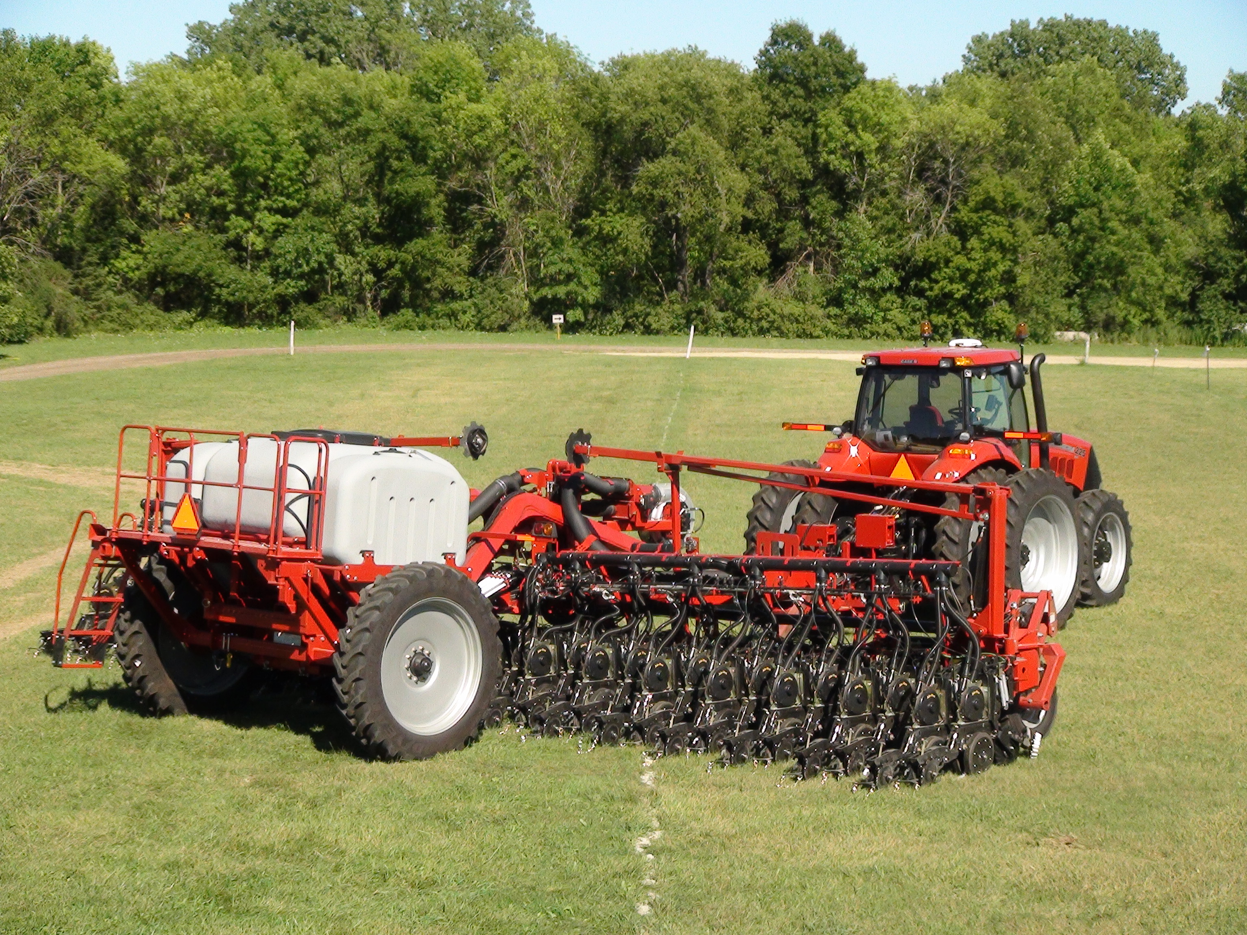

**Photo caption:** Twin-Row planters are the newest addition to the Case IH planter family. This technology allows producers to use higher plant populations, which pay dividends in higher yields.